**Bold Elegance with Industrial-Chic Metal Mirrors**

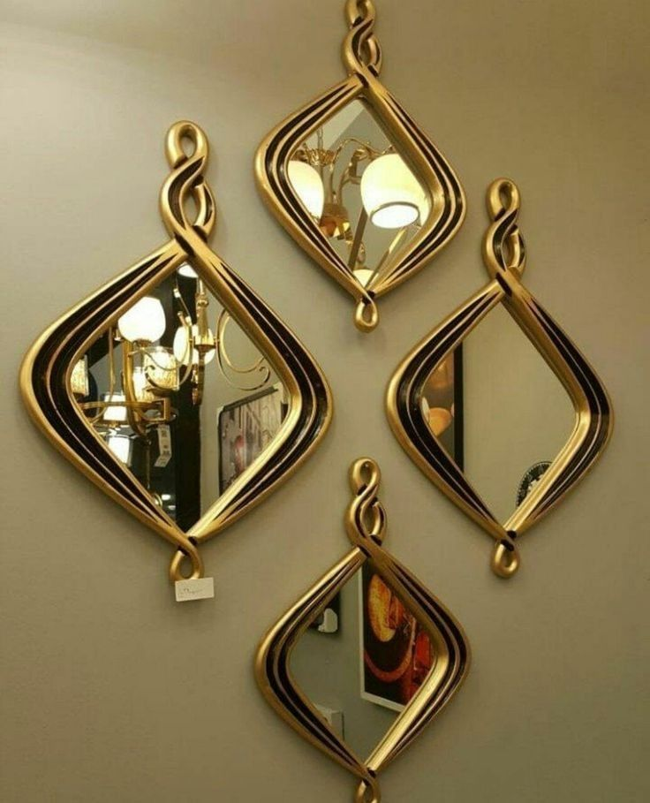Metal Mirrors combine strength with sophistication, offering a bold design statement that suits both modern and industrial-style interiors. With sleek metallic frames — ranging from matte black and brushed gold to antique bronze — these mirrors add depth, texture, and a refined edge to any room.

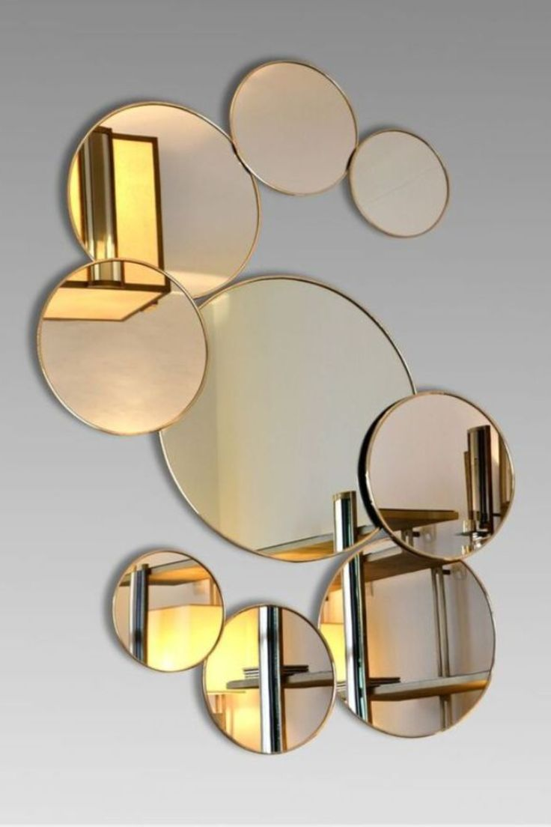Their sturdy construction ensures long-term durability, while the reflective finish of the metal frame enhances the overall aesthetic of the space. Whether used as a dramatic focal point in living rooms or a stylish accent in bathrooms and entryways, metal mirrors bring a timeless charm with a modern twist.

Perfect for those who appreciate clean lines and architectural details, metal-framed mirrors balance form and function effortlessly, making them a striking addition to minimalist and contemporary homes alike.

Add a touch of industrial grace and modern luxury with metal mirrors that stand strong — and shine bright.